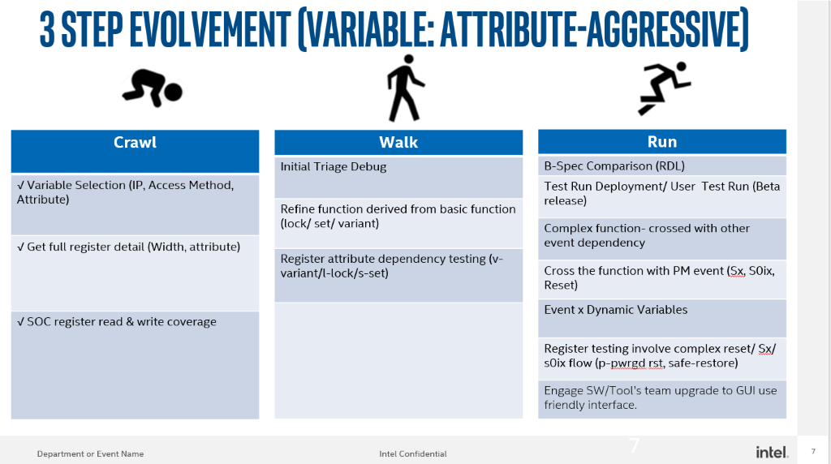

|  |  |
| --- | --- |
| Crawl | Status |
| Variable Selection (IP, Access Method, Attribute) | DONE |
| Get Full Register Detail (Width, Attribute) | DONE |
| SOC Register Read & Write Coverage | DONE |
| Walk | | Status |
| Initial Triage Debug Information (Log File; Error message) | | DONE |
| Refine Function Derived From Basic Function (Lock/Set/Variant) | | DONE |
| Register Attribute Dependency Testing (v-variant/ l-lock/ s-set) | | WIP |

|  |  |
| --- | --- |
| Run | Status |
| B-Spec Comparison (RDL) |  |
| Test Run Deployment / User Test Run (BETA release) |  |
| Complex Function - cross with other event dependency |  |
| Cross the function with PM event (Sx, S0ix, Reset) |  |
| Event x Dynamic Variables |  |
| Register testing involve complex reset/ Sx/ S0ix flox (p-pwrgd rst, safe-restore) |  |
| Engage SW/ Tool's Team Upgrade to GUI use Friendly Interface |  |